**THE MAHARAJA SAYAJIRAO UNIVERSITY OF BARODA**

**FACULTY OF TECHNOLOGY AND ENGINEERING**



**A PROJECT REPORT**

**on**

**Diamond Package Manager**

***Submitted by***

**Yogesh Agrawal, Shubham Donda and Keshav Kharate**

***In fulfilment for the course of* Java Programming (MCA1202) *Of***

**MASTER OF COMPUTER APPLICATIONS**

**in**

**The Department of Computer Science and Engineering**

July 14, 2022.

**Name and PRN**

Yogesh Agrawal (8021041994)

Shubham Donda (8021076019)

Keshav Kharate (8021062985)

# Abstract

This document is intended to report Java mini project by students of Master of Computer Applications – i.e., ours. This report discusses our experience as a software developer in a project from May 2022 to June 2022.

In this project, we have created an application for diamond management which manages the details of Raw Materials, Rough Diamond Packet details, process status and Employee Details. It also Stores the whole data in Database.

# Table of Contents

Abstract 2

Table of Contents 3

Preface 4

Acknowledgment 5

About Project 6

Tools, Technologies, Libraries & Features 6

UML Diagrams 8

Screenshots & Explanation 12

Reports 16

User Manual 17

References and Bibliography 18

Conclusion 19

# Preface

After studying Java for a semester in SSMCA, we got to imply our knowledge of coding / programming, teamwork, communication skills, tools, strategies, and creativity into this project.

This project is for a subject of second semester of Master of Computer Applications whose subject code is ‘MCA1202’. It must be completed by group of three students.

“Diamond Package Manager” is the project of our group , which includes 3 members (us): Yogesh Agrawal , Somprakash Pradhan and Chirag Patel.

This project is designed to know the details about status of Diamond Process and availablity Status which Can be used in diamond Industry.

As the term of semester 2 is coming to an end, we are submitting this document to our course teacher Ms. Mamta Padole, which includes diagrams, strategies, features and limitations of an application.

In this document, we tried to make everything i.e., sections and diagrams with explanations, consistent, subsequent, and easy to interpret by anyone who knows at least basics of software engineering.

As this document will not be read by only faculties but also by junior students of our succeeding batch to document their project like this. With this concern in mind, we are putting strategies and methods along with appropriate UI, which we have considered while working.

# Acknowledgment

Foremost, we would like to express our sincere gratitude…

To Dean of the Faculty of Technology and Engineering, Prof. (Dr.) Chivukula N. Murthy and our Head of the Department, Prof. (Dr.) Apurva M. Shah for providing us an opportunity to show our knowledge which we gained here; And for sharing their personal experiences about system and software development on-field, too.

To our subject teacher, Ms. Mamta Padole for advising us throughout the project with her personal experience and professional ideas, who did not only recognize our mistakes but helped to solve them. We feel blessed bcause of her.

# About Project

**What was the need of this application?**

As we all know that Dimond is expensive Substance which is used in Making Jewellery, Automotive Industry and many other tasks. Therefore, in Diamond industry it is necessary to manage the Production of Diamond properly and the key person of company should have should have knowledge about the Status of a Production(i.e., which Employee is doing which process on particular raw material and what is a status of a product etc.).

**How did we define the project? And what is the scope & purpose of it?**

As we know that managing different processes while manufacturing a product (Diamond in this case) is very difficult job. So, we decided to develop our own application named “Diamond Package Manager” which manages all the details about the production of a product. This application will help the manufacturer to get whole the details like what is the status and size of a raw material (Rough Diamond in this case) and which employee is working on which rough diamond etc on his computer screen in just one click.

We have created different java file which stores and display the size, process details for respective raw material. Also, we used Xampp server for storing and accessing data which uses SQL as query language which we learn in the Second Semester of MCA-1 in the Academic year 2021-22. The scope of the Subject is quite wide and requirement of an application could probably be changed over the time. To cover the scope of the subject, probably more tools would be used, or quite big interventions to selected tool would be required. But in the time being we start from the basic requirements for Diamond industries.

As a development platform for the project, we had to work on Java, ensuring high portability and very good support by available tools and NetBeans IDE. Another important decision to make was the selection of component framework Swing to make GUI which makes our application more Attractive.

# Tools, Technologies, Libraries & Features

* IDE (Integrated Development Environment) o **NetBeans IDE**: It includes a text editor, a compiler, and a display window. It enables the creation of software within a carefully designed set of constraints.
* Libraries :
  + **Controlp5**: It offers a range of controllers that allow us to easily change and adjust values while our sketch is running. Each controller is identified by unique name assigned when creating a controller. ControlP5 locates variables and functions inside our sketch and will link controllers to matching variables or functions automatically. Controller changes can easily be captured within our sketch by implementing the control Event function.
  + **JDBC :** Java Database Connectivity is API which provides universal data access from the **Java programming language.** Using the JDBC API, you can access virually any data source, from relational database to spreadsheets and flat files.
* Features of Java we employed within our project are as follows:
  + **Packages:** Java Package is a group of similar types of classes, interfaces and sub-packages which use to achieve DRY -DO NOT REPEAT YOUR SELF Principle
  + **Swing**: Java Swing is a lightweight Java graphical user interface (GUI) widget toolkit that includes a rich set of widgets.
  + **Collections**: It is a framework that provides an architecture to store and manipulate the group of objects.
  + **OOPs**: It is about creating objects that contain both data and methods. It is a paradigm that provides many concepts, such as inheritance, data binding, polymorphism, etc.

# UML Diagrams

## Use Case Diagram:

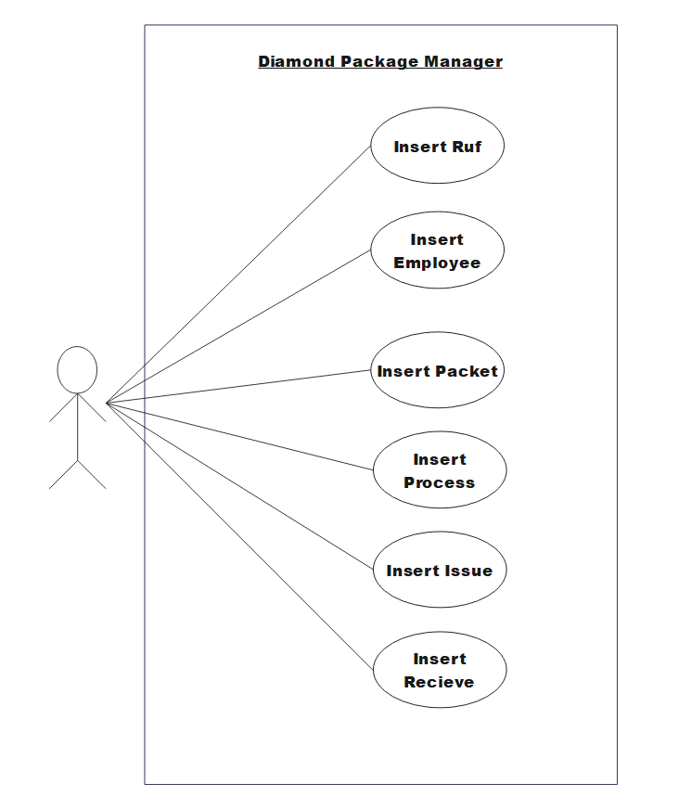

## Activity Diagram:

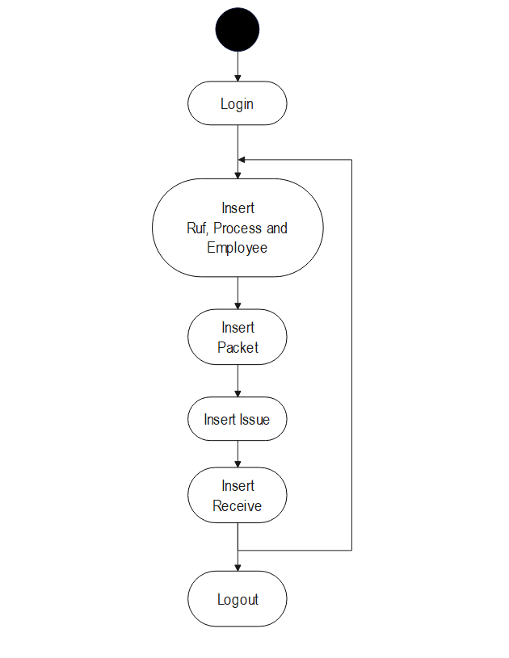

## Sequence Diagram:

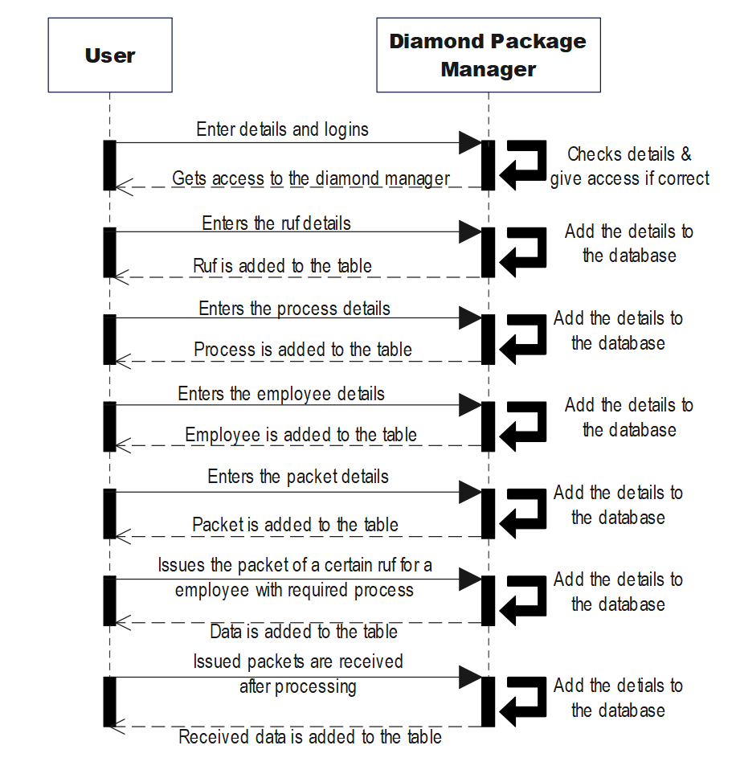

# Screenshots & Explanation

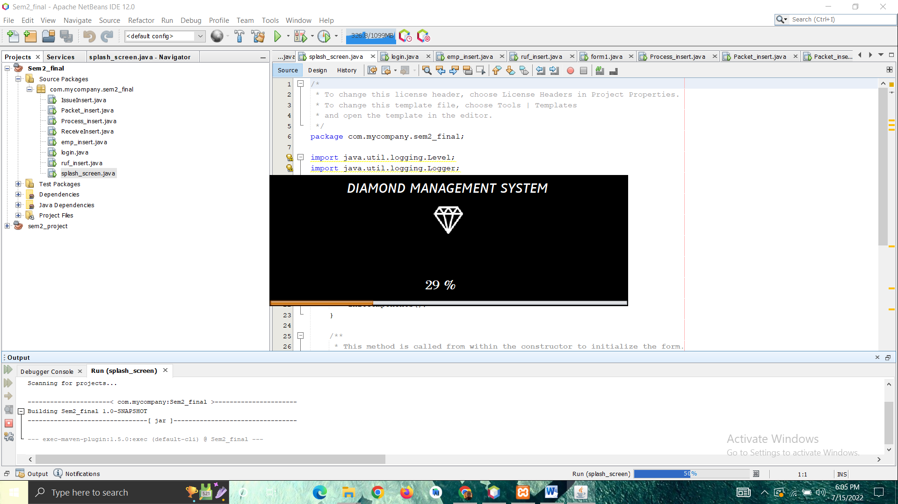

Fig. Splash Screen

This page appears first when the project is executed. It is the splash screen used for showing that project is about to execute. It has a panel, a progress bar and some label to show.

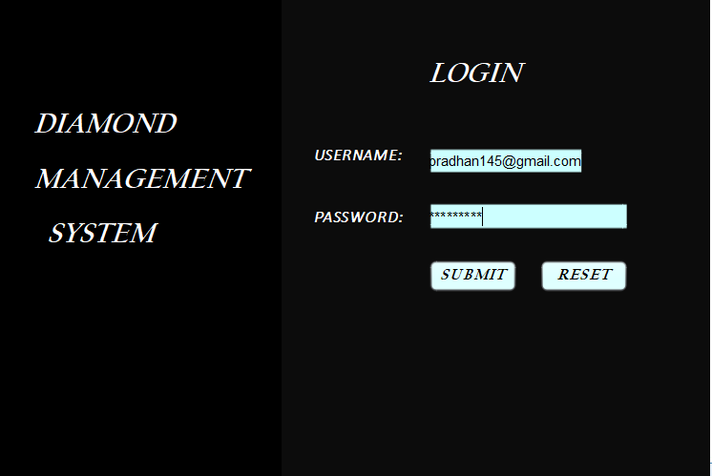

Fig. Login page

Above page shows the login page for the user, where the user can login to the system. It has 2 panels.

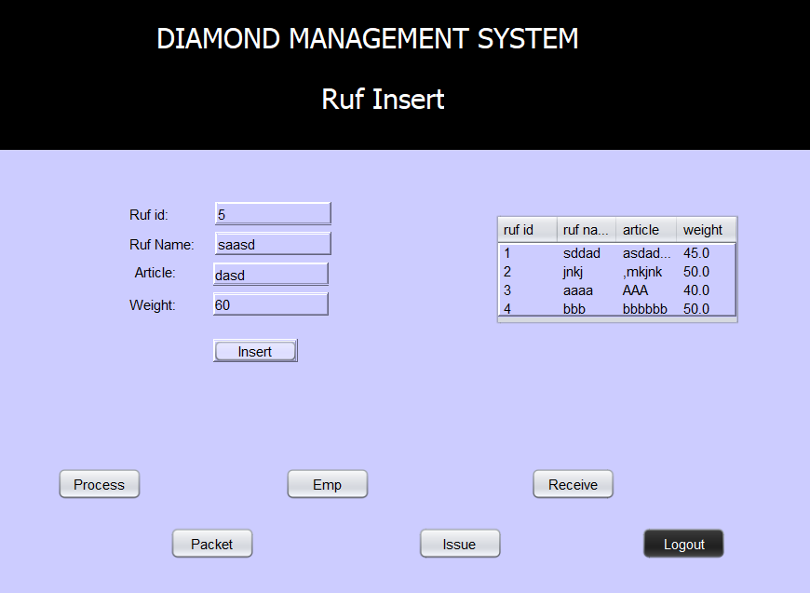

Fig. Ruf Insert page

The above page shows the insertion of the Ruf details. Ruf means raw materials for the Diamond. So the details of the ruf are inserted in this page. As the data is inserted, the inserted data will be seen in the table. Below buttons are used to navigate to other pages.

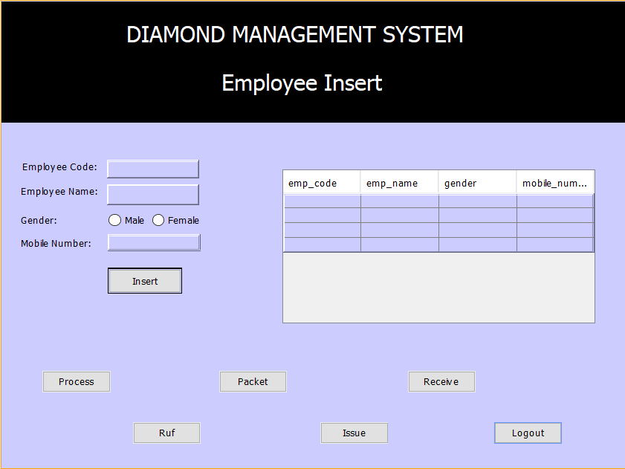

Fig. Employee insert page

Above page is also the insert page but for the insertion of the employees. And other features are same.

There are also process insert page & packet insert page for the same. Process page has the data for the process which the diamond has to undergo. And packet page has the data of the packets which are divided from the Ruf diamond.

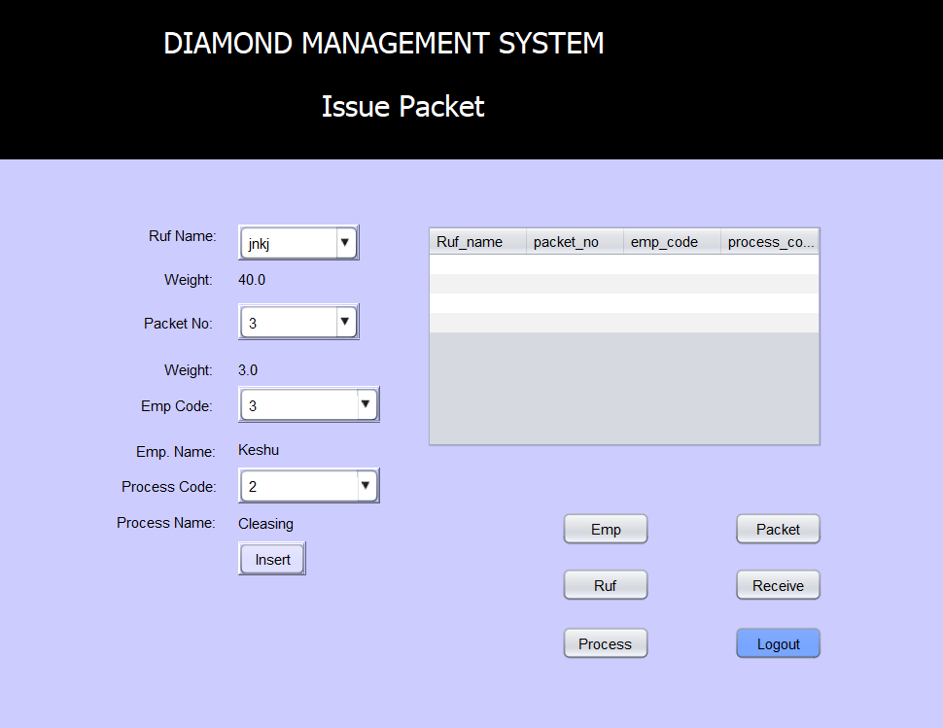

Fig. Issue packet page

This page is used for issuing the packets for a particular Ruf by a specified employee and for a specified Process. This makes the issue of a packet and inserting the data in the issue table.

Similarly, there is a Receive page that is used for receiving the packet that is issued before by the user.

By receiving the weight of the packet gets decreased as it goes through a certain process.

# Reports

Due to the summer holidays, we were not obliged to show our regular updates of the project to the course teacher, hence, we do not have any reports to put here.

# User Manual

This section of the report is meant for the users to interact with our application, using which they can easily interact with it.

For accessing this project, you need to install Java and other binaries for executing this application.

This In our application, we have provided the Diamond management system. This system can be used for the managing all the diamond materials in a company with details. Here, only the authenticated admin can get access to the data.

After executing the project, the splash screen pop ups. And then login page is executed automatically. Admin must login the system by entering his username and password & clicking the submit button. After successfully login, the admin will be automatically redirected to the ruf insert page. He/She can insert ruf details and can see the details of the ruf.

Admin can also insert its packet details, employee details and process details. The link to different insert pages are there in same section in the form of buttons. These pages work same as the ruf insert page as described earlier. User (here Admin) can also issue the packets by inserting data into it. Issuing of packet refer to pursing a certain piece of diamond for a required process by the exsisting employees.

User can also receive the packet that were earlier issued by the employee. Once the work is finished, the user can logout from the system as no other unauthorized system can access or manipulate the data.

# References and Bibliography

* Stack Overflow. (n.d.). *How to program this GUI in Java Swing*. [online] Available at: https://stackoverflow.com/questions/15363706/how-to-program-this-gui-in-java-swing [Accessed 15 Jul. 2022].
* www.javatpoint.com. (n.d.). *Java Swing Tutorial - javatpoint*. [online] Available at: https://www.javatpoint.com/java-swing.
* Anon, (n.d.). *Java Swing Application with Database Connection*. [online] Available at: https://www.javaguides.net/2019/07/java-swing-application-with-database-connection.html.

# Conclusion

This project boosted our knowledge and skills required in a corporate world specifically. Also, it exposed us to new technologies like processing and its whole environment of libraries and allowed us to improve on our previous knowledge of JAVA. We learnt teamwork, planning and human resource management.

In our team, there was a vast difference between the knowledge of the members, so, it was hard to keep everyone on the same page, but we learnt to overcome those limitations and finally achieved our goal.

